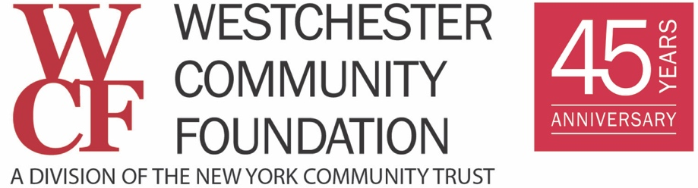

Westchester COVID-19 Response Fund
Introduction

The Westchester COVID-19 Response Fund requests proposals from human services nonprofits serving Westchester residents.

Consideration for grants is limited to 501c3 nonprofit organizations, groups fiscally sponsored by a 501c3 nonprofit organization, or other charitable organizations able to receive tax-deductible contributions, such as schools, faith-based organizations serving community needs, and other public entities based in or primarily serving Westchester County communities and residents.

Grants will cover up to four months of your organization’s unanticipated expenses due to the coronavirus crisis and are expected to be between $5,000 and $50,000.

Grants will not make up for lost fundraising event revenue. These grants must be used for unanticipated, additional expenses related to coronavirus. Services not eligible for funding: arts, animal welfare, and environment.

Note: These parameters may change in response to the situation and organizational needs. All such changes will be communicated on our website. The near-term goal of the Fund is to provide a rapid response that delivers financial resources to address immediate needs.

Fundraising and the distribution of resources will continue through the outbreak and into the recovery phase, which has an unknown timeline.

As we are dealing with unprecedented and unpredictable short- and long-term implications of COVID-19 on our communities and neighborhoods, we will frequently review the Fund’s criteria for grantmaking to ensure we are responsive to the changing needs of our communities based on the dynamic nature of this crisis.

APPLICATION FORM

Organization Name (and DBA if different):

Main contact email and phone:

Annual Operating Budget:

Grant Amount Requested:

Eligible nonprofits may request funding in one or more of the categories described below.

Please check the category or categories for which you seek support.

___ Equipment to comply with public health measures designed to slow the spread of COVID-19, including remote work and social distancing. Examples include:
- technology (remote conference capacity, laptops, online program delivery)
- emergency supplies (cleaning supplies and services) personnel costs related to COVID-19

___ Personnel costs related to COVID-19. Examples include:
- hiring temporary staff to cover shortages caused by employees who are ill, may have to quarantine, or stay home to care for family members or children during school closures
- payroll obligations jeopardized by lost revenue resulting from facility closures and/or cancelled services or programming (grants will not make up for lost fundraising event revenue)

___ New and emergency needs, particularly for service offerings outside normal operations to respond to quarantine, social distancing, and isolation. Examples include:
- expanded meal delivery for at-risk residence who are newly homebound or quarantined
- protocols to keep housing insecure residents sheltered while reducing the spread of the virus
- increased costs to safely shelter clients who must be quarantined because they may be exhibiting symptoms

QUESTIONNAIRE

Please answer the following questions succinctly.

Describe the population your organization serves, including age, geographic area, and any other relevant common characteristics, i.e., disability or immigration status. (250 words or less)

Describe the COVID-19 issues your organization is facing—both internally and in meeting the needs of your clients. (400 words or less)

How will the requested funding help your organization address the COVID-19 issues you described for each category you checked above? (400 words or less)

Budget: for each category of funding requested above, please indicate how much you are seeking and itemize how you would spend the funds, i.e., how much will be spent for equipment (including the quantity and cost of the equipment); personnel (including titles); and new program-related costs. (250 words or less)

Please attach your most recent operating budget to the email.

Submission Instructions:

In a single email to covidfund@wcf-ny.org, please attach this document and your current operating budget.

Please put COVID-19 in the subject line of your email and in the name of the document, along with the name of your agency.

Proposals will be reviewed on a rolling basis. Applicants will be notified by email. Additional limited information may be required.

