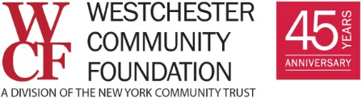
COVID-19 Technology Technical Assistance Grants

Request for Proposal

IT Support
The Westchester Community Foundation is offering COVID-19 Technology Technical Assistance Grants to help nonprofits adapt effectively and efficiently to long-term remote work and service delivery.
The Foundation has assembled a list of five vetted IT managed-service providers (MSP) for this program. Nonprofits will be matched with one of these MSPs, who will conduct an IT assessment of the organization’s technology assets and cybersecurity protocols, and develop recommendations and a budget for additional hardware, software, staff training and cybersecurity needs.
Costs up to $25,000 will be considered.

GRANT PROGRAM
Grants from $10,000 to $25,000 will be made available to nonprofits for one year of managed IT services, which will include:
- Assessment of hardware and software needs
- Assessment of cybersecurity and protocols
- Assessment of IT training needs
- Funds to support the purchase of recommended additional and/or updated hardware and software and to upgrade the organization’s cybersecurity protocols
Expenses that will not be considered:
- Costs of technology (hardware, software, phones) purchased prior to proposal submission
Organizations applying for this grant acknowledge that if the grant is awarded, the organization will be responsible for securing funding for any managed IT services it contracts for after the 12-month grant period has ended.
***

Criteria for Participation
- Organizations must be a 501(c)(3) based in Westchester County.
- Organization will not have either an IT professional on staff or a managed service provider under contract currently.
- They will be able to assign a contact person for the period of engagement.

APPLICATION DEADLINE IS FRIDAY, OCT. 30.

